Purpose – to create a mini-version of the various processes in play in our backup/recovery/DR plan.

The “mytest” share, NY snaps, replication and Ithaca snaps created 5/25. Screenshot showing simulated user folder (XYZ2001) created 5/25.

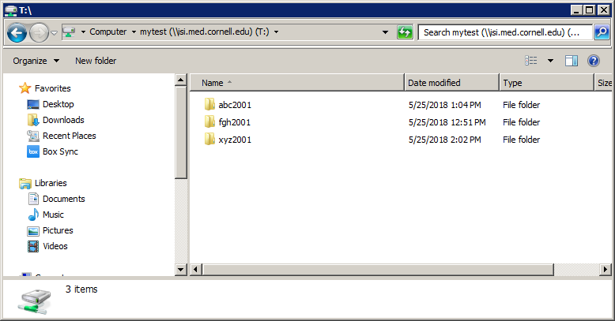

NY snapshots 1 per hour (between 1PM-4PM). View of parent folder (root of “mytest” share) properties dialog showing previous versions available to restore.

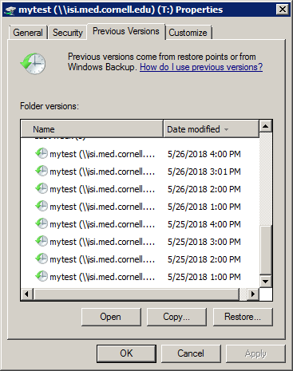

NY Isilon Bash command showing schedule above plus retention of 8 days

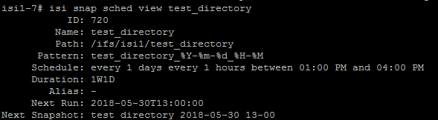

XYZ folder in NY deleted 5/29 AM

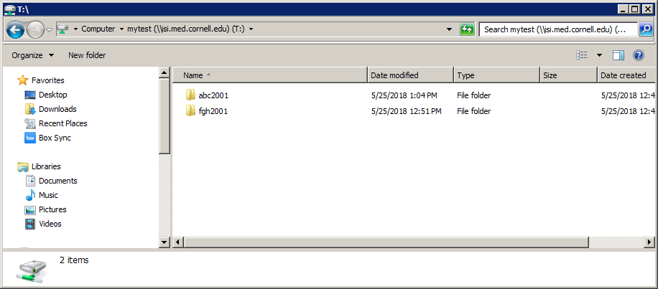

Changes replicated to Ithaca via SyncIQ “sync” job later AM

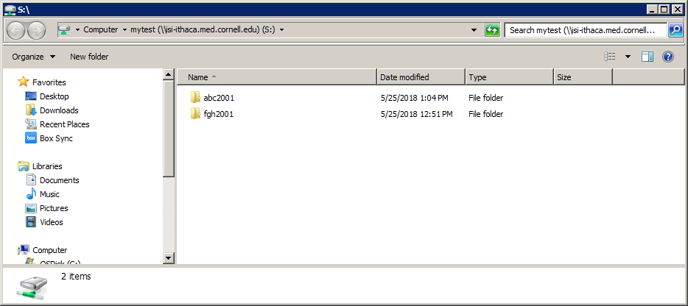

Ithaca snaps are also 1 per hour but with retention of 22 days. This was adjusted later to change the time scale during testing.

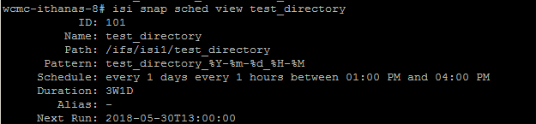

View of snapshots available for restore in Ithaca.  
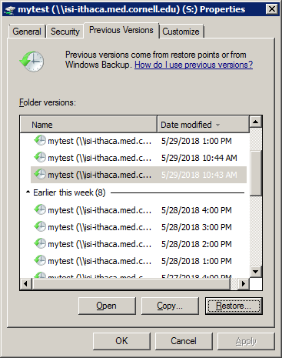

Opening first Ithaca snapshot after successful replication from NY (5/27 – note date in title bar) reveals deleted folder which can be restored.   
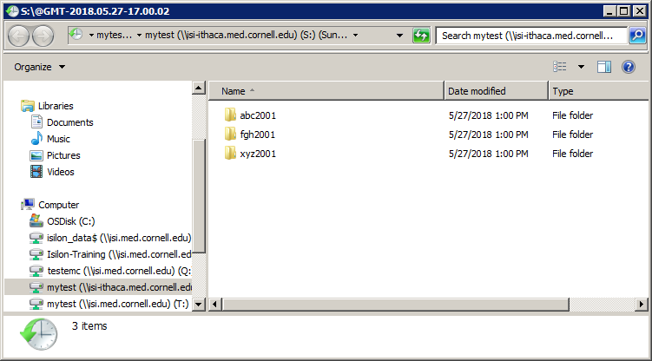

Adjusting snapshot expiration times (called “duration”) to speed up the time scale of the experiment.

Expiring snapshots – 5/30. Modified snapshots in Ithaca to expire in 3H

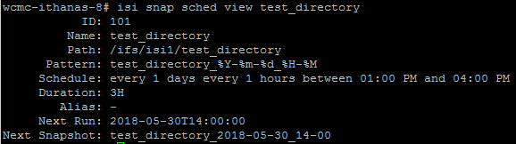

Example of one snapshot after the alteration (Created 5/27 1PM, expires 5/30 2:34PM)

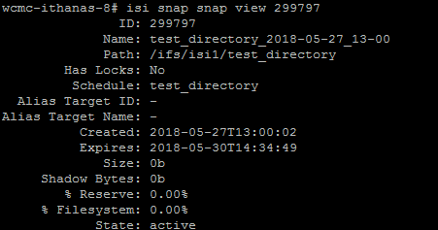

After allowing the older snapshots to expire, they no longer appear in Ithaca as previous versions  
